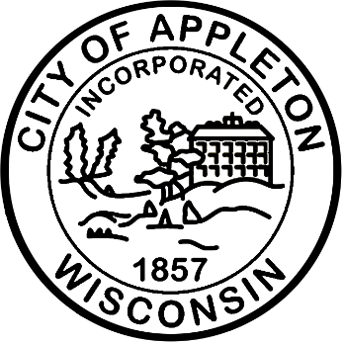

City of Appleton
Fleet & Parking Maintenance Technician– 2nd Shift

Come join the City of Appleton and thrive! Here at the City, you’ll have the opportunity to work in a forward-thinking, positive environment alongside other caring team members. You’ll be challenged by rewarding work that impacts the lives of community members each day. You’ll expand your skills and knowledge through training and growth opportunities. You’ll be respected and appreciated for sharing your ideas and bringing your authentic self to your work. And you can celebrate your successes with your loved ones because of the great flexible work arrangements the City offers. Come join our team—you belong here!

The City of Appleton is currently accepting applications for a vacancy in Public Works. This is manual labor responsible for minor maintenance and cleaning of City vehicles/equipment in the Central Equipment Agency Division and maintenance of equipment/parking ramps of the Department of Public Works. Work involves inspecting and performing minor vehicle/equipment maintenance, custodial functions for Parking, and miscellaneous duties in emergency situations. Work is performed under regular supervision of the C.E.A. Fleet Manager and the Parking Utility Manager. Employee must be able to effectively deal with the public.

Qualifications
Candidates should have some experience of a mechanical nature and training beyond the high school level or an equivalent combination of experience and training. This is a second shift position, Monday – Friday 3:00 PM – 11:30 PM.

Salary
The hiring salary range for this position is $23.00 – $24.66, with the ability to earn up to $27.84 hourly. Plus, an excellent fringe benefit package including paid time off, health, life, dental, and Wisconsin Retirement System (WRS). The WRS is among the best funded and best managed public pension systems in the country.

Apply Now!
If you are interested in applying for this position, please complete an on-line application at www.appletonwi.gov/careers by no later than Sunday, August 16, 2026, at 11:59PM. Resumes without an application will not be considered.

City of Appleton Human Resources
100 N. Appleton Street, 6th floor
Appleton, WI 54911
Phone: (920) 832-6458
Email: humanresources@appletonwi.gov
Equal Opportunity Employer

